Instructions for Getting Started with Ozone Widget Framework:

1. Go to <https://www.owfgoss.org> and click “Download OWF”

2. Once it is done locate it in the directory in a terminal window.

3. In the terminal window cd into the bin folder

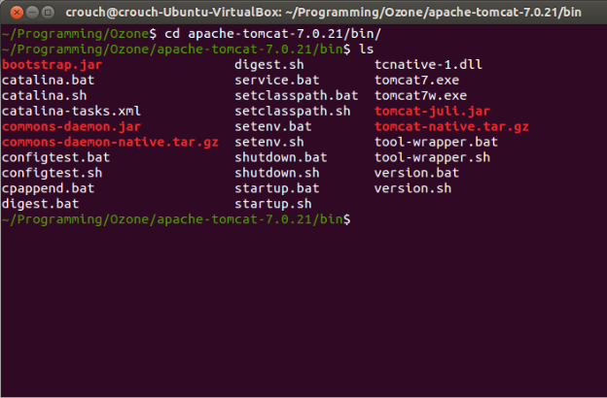

4. In this folder type “bash ./catalina.sh run”

\*Note: If Ozone Widget Framework does not start up using the command “bash ./catalina.sh run” as described, it may be because an instance of Tomcat is already running, hence the script is unable to bind to that port. You will see errors that say something like “unable to bind…”

In this case, try:

“sudo service tomcat7 stop”

then type:

“bash ./catalina.sh run”

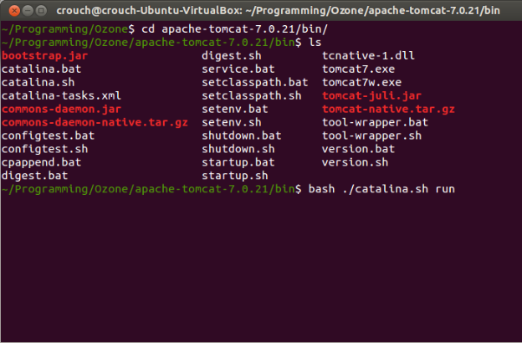

5. The local server should start up and can be visited at <https://localhost:8443/owf>

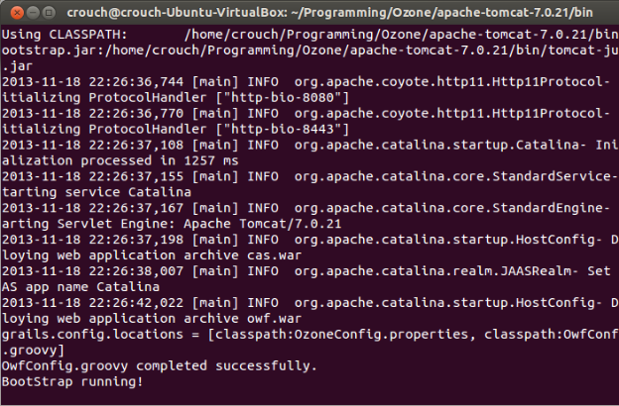

6. Login using the default username “testAdmin1” and the password “password”